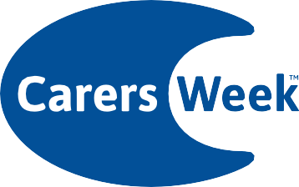

Are you looking after someone?

10–16 June 2024

For more information visit

carersweek.org

© 2024. Carers UK is a charity registered in England and Wales (246329) and in Scotland (SC039307) and a company limited by guarantee 864097. Registered office 20 Great Dover Street, London, SE1 4LX

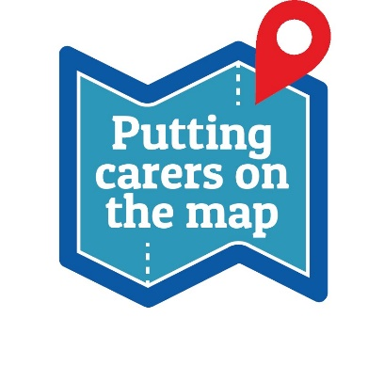

If you are an unpaid carer in Brooklands and Northenden, come and visit our drop in Carers Event for free support from local organisations!

Free blood pressure readings (in the morning)

Information and advice from local services

Date: Thursday 13th June 2024

Time: 9am-11am, 4pm-6pm

Where: Northenden Health Centre, 489 Palatine Road, Northenden, M22 4DH

Due to limited parking, please walk, cycle, or use public transport where possible (number 41, 43, 101, 103, 370/371 buses stop nearby)

For more information, contact your care coordinator at your GP practice, or Zoe on 07787 493 406

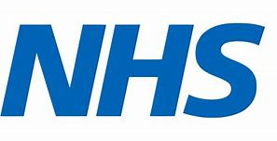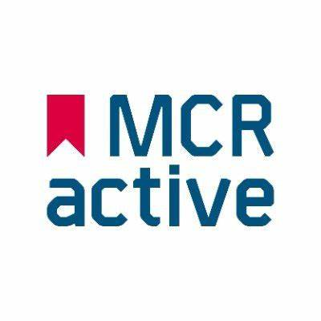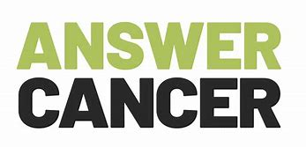

…and more!