**Friends and Family - May**

Our May Friends and Family results are now in!

Patients are asked via SMS to rate the service they receive after having an appointment at the Practice.

136 out of 146 (93%) of patients who responded say we were good or very good!

THANK YOU!

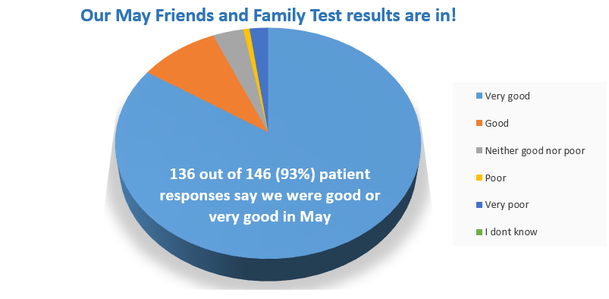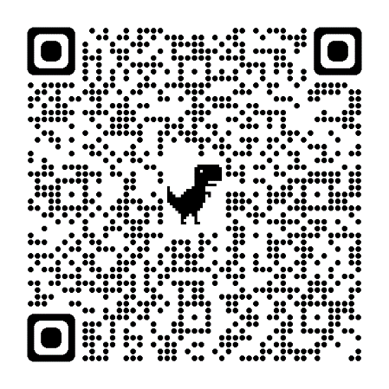

You can also leave us feedback by scanning the QR code to the right on your smart phone, or by completing a paper version located in Reception.